ED1 - Introduction to Education
Please note that the sociology of education focuses on the English/UK Education system.

Types of School in the UK
State Schools
- State Schools refers to government-funded schools which provide education free of charge to pupils.
Private Schools
- Private Schools refers to schools which charge fees, these can be boarding or day.
Public Schools
- Public Schools are long established schools which are fee paying but students need to pass an exam (usually the Common entrance exam) in order to secure a place.

Private and public schools are often combined under the heading of independent schools because they are independent of the regulations and conditions which apply to state funded schools. They may choose to follow some regulations such as Curriculum or the type of examinations they choose to do but they don’t have to.

The Stages of the Education system in the UK:

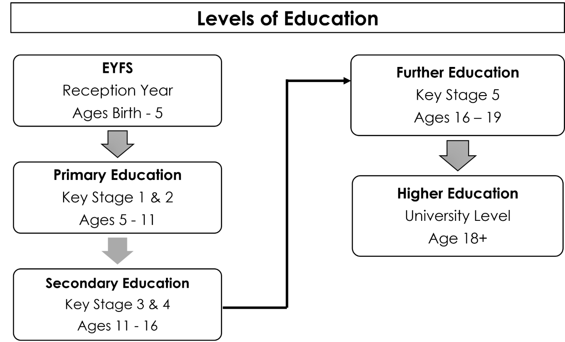

Types of State Schools in the UK
Community schools or maintained schools
Funded by the local authority and not influenced by business or religious groups and follow the national curriculum
Foundation and voluntary schools
Funded by the local authority but have more freedom to change the way they do things – sometimes they are supported by representatives from religious groups.
City Technology Colleges (CTCs)
All-ability secondary schools based in urban centres and geared towards science, maths, technology and preparing students for the world of work. However, they also teach the National Curriculum and offer a range of qualifications, from vocational through to GCSEs and A Levels. 15 City Technology Colleges were created, of which all but three have converted to academies.
Grammar schools
State secondary schools that are free to attend but select their pupils by means of an examination taken by children at age 11, known as the “11-plus”. There are only about 163 grammar schools in England.
Academy Schools
State-funded schools in England which are directly funded by the Department for Education and independent of local authority control. Academies are self-governing non-profit charitable trusts and may receive additional support from personal or corporate sponsors, either financially or in kind. They do not have to follow the National Curriculum but do have to ensure that their curriculum is broad and balanced, and that it includes the core subjects of mathematics and English.
Free Schools
Funded by the government but are not run by the local authority. They have more control over how they do things. They’re ‘all-ability’ schools, so can not use academic selection processes. Free schools can set their own pay and conditions for staff, change the length of school terms and the school day, They do not have to follow the national curriculum. Free schools are run on a not-for-profit basis and can be set up by groups like, charities, universities, independent schools, community and faith groups, teachers, parents, businesses.
Faith Schools
These have to follow the national curriculum, but they can choose what they teach in religious studies. Faith schools may have different admissions criteria and staffing policies to state schools, although anyone can apply for a place.
Single Sex Schools
Schools which select based on gender. They are 100% Male or Female in the student body, although many become co-Ed at 6th form level.
A State Boarding School
A boarding school where you pay for boarding but the education is free. The government pays for the education as it would at any other state school in England. Most state boarding schools are academies, some are free schools and some are run by local authorities. State boarding schools give priority to children who have a particular need to board and will assess children’s suitability for boarding. International students must have a UK address to be eligible for a place. There are around 40 State Boarding Schools in the UK.

Alternative Provision
Alternative provision (AP) is education outside school, arranged by local authorities or schools, for pupils who do not attend mainstream school for reasons such as school exclusion, behaviour issues, school refusal, or short- or long-term illness.
Alternative Provision can include:
Pupil Referral Units
- For students who have been excluded from mainstream education.
Special Education Schools
- For students who are unable to access mainstream education due to physical or mental disability, developmental or behavioural issues.
Home Schooling
- Some parents may choose not to send their children to a mainstream school and instead prefer to education their children at home. Home Schooled children must be registered with the local authority and are subject to checks by the local authority.

Factors affecting choice of school
Each of these types of school have their strengths and limitations, and the decision of which type of school a parent wishes to send their child to can link to those strengths and limitations. However there are a number of other factors which also impact that decision. Including:
A Parents Personal Experiences of Education
- A negative experience in a certain type of school may put off parents from sending their child to a particular type of school, just as a positive one may increase their desire to send their child to a certain type of school.
Personal Values and Beliefs
- Parents and family beliefs and value may influence a parents choice of type of school, this is particularly apparent with religious beliefs.
Economic factors
- Economic factors such as fees, might influence a parents decision to send their child to private school or a state school. Other economic factors such as travel might also play a role if there isn’t the type of school the parents want to send their child to in the local area.
Geographical Factors
- There are some types of schools which are not common around the UK, for example there are only 40 State Boarding Schools and 15 City Technical Colleges in the UK. This may impact the type of school that parents send their children to.
Availability
- Although state schools have open enrolment (meaning anyone can apply) some schools are more popular than others, this can limit the availability of places and the choice of which school to send children to.
Personal Needs
- Depending on the family’s personal needs and situation can influence the type of school a parent wants to send their child to. For example Parents who work in highly mobile occupations, military for example, this may mean they choose a Private or State boarding school for their child.

